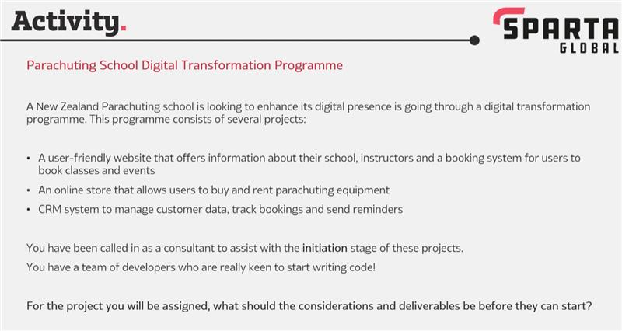

**Project 1:** User friendly website that offers information about their school, instructors and a booking system for users to book classes and events

**Considerations (Planning):**

* Stakeholders: marketing, developers, business analyst, project manager,
* Scale of the project: how big is the project scale wise? global/national
* Time taken to finalise the project
* Understand target audience
* Risk Assessment
* Budget

**Deliverables**:

* Training,
* Software & hardware (Wix, Data Tools, etc)
* User manuals
* Front & backend
* User friendly features
* Data security
* Payment
* Confirmed budget
* Identify risks

**Goals:** to find the objectives & requirements of the projects, under this what are the deliverables?